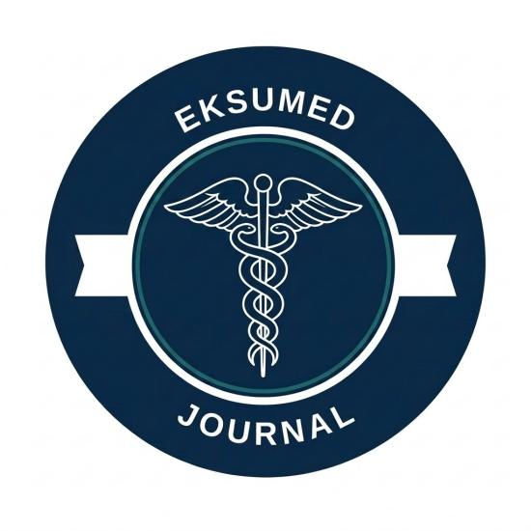
EKSUMED JOURNAL

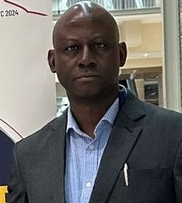

Editorial Advisor| PROFESSOR JOSEPH O. FADARE (MD, MA Bioethics, FMCP (Clinical Pharmacology and Therapeutics, FNAMed, FAMedS)
Professor Joseph Fadare is a Professor in the Department of Pharmacology and Therapeutics and Medicine, College of Medicine, Ekiti State University, Ado-Ekiti, Nigeria. He is also a Consultant Physician/Clinical Pharmacologist at Ekiti State University Teaching Hospital, Ado-Ekiti, Nigeria.
Prof Fadare is a fellow of the National Postgraduate Medical College of Nigeria (FMCP) in the subspecialty of Clinical Pharmacology and Therapeutics. He also holds a Master’s degree in Bioethics with interest in research and medical ethics. As a recognition of his research efforts and scholarship, he was elected Fellow of the Nigerian Academy of Medicine and Academy of Medical Sciences in 2022 and 2024 respectively.
Prof Fadare has over 20 years work experience as a lecturer, researcher and consultant physician/clinical pharmacologist training both undergraduate medical students and residents in the specialty of Clinical Pharmacology and Therapeutics and General Medicine.
He is a member of several professional societies such as Nigerian Society of Clinical Pharmacology and Therapeutics (currently serves as the President), Medicines Utilisation Research in Africa (MURIA), British Society for Antimicrobial Chemotherapy (BSAC), American Society for Microbiology (ASM), European Society for Clinical Microbiology and Infectious Diseases (ESCMID) and International Society for Pharmacoepidemiology (ISPE).

His research interests are in the following areas: pharmacoepidemiology and drug utilization (including antimicrobials), antimicrobial stewardship, pharmacovigilance, geriatric pharmacology, clinical trials and medical ethics.
Professor Fadare has published extensively in his chosen areas of research with over 180 publications in peer-reviewed journals and four book chapters. He is a reviewer for many highly ranked journals including PLOS One, Lancet Infectious Diseases, British Journal of Clinical Pharmacology, BMJ Open, Frontiers in Pharmacology, Frontiers in Public Health to mention a few. He is an academic editor with PLOS One and associate editor for Frontiers in Pharmacology.
Prof. Fadare is the current editor-in chief of the Nigerian Stethoscope (a journal jointly owned by the Medical and Dental Consultant Association of Nigeria (MDCAN EKSUTH), Ekiti State University College of Medicine and the Ekiti State University Teaching Hospital). This journal is in its 8th year of operation with prompt and timely publication of issues. He is also an editor with the journal, Tropical Journal of Clinical Pharmacology and Therapeutics, a journal of the Nigerian Society of Clinical Pharmacology and Therapeutics. Prof. Fadare has served as external examiner in Pharmacology and Therapeutics to many medical schools in Nigeria and also an examiner in the Faculty of Internal Medicine, National Postgraduate Medical College of Nigeria. He has also served as external assessor for MSc thesis to Stellenbosch University and Sefako Makgatho Health Sciences University, South Africa and University of Namibia. Professor Fadare has also served as examiner for PhD dissertations in Pharmacy to Sefako Makgatho Health Sciences University and North-West University both in South Africa.
Professor has served as Dean, Faculty of Basic Clinical Sciences, Ekiti State University. He has also served as Chairman, Committee for Evaluation of Books and Manuscripts, Ekiti State University. He is the current Chairman of the Research and Ethics Committee, Ekiti State University Teaching Hospital, Ado-Ekiti, Nigeria. He serves as resource person for accreditation of medical programmes to the Medical and Dental Council of Nigeria. He has also served as resource person to the Federal Ministry of Health and Social Welfare in guidelines development especially regarding rational use of medicines. Prof Fadare also serves as a resource person (expert assessor) to British Society for Antimicrobial Chemotherapy (BSAC) program on Global Antimicrobial Stewardship Accreditation Scheme.
He is married with children.



AJAYI Marvellous | Editor-in-Chief

Marvellous Ajayi is a fifth-year medical student at Ekiti State University (EKSU), Nigeria, working at the intersection of clinical medicine and digital health infrastructure. His research centers on continuity of care and interoperability as foundations for responsible AI adoption in African health systems, a thesis he has developed across academic, entrepreneurial, and policy-facing work. He is the Founder and CEO of CAREFLOE, a digital health company building continuity-of-care infrastructure for African health systems. He currently serves as Regional Director of Research Works for NiMSA Southwest Region and Editor-in-Chief of the EKSUMSA Journal Club, and has accepted abstracts and invitations at international health conferences across Africa, Europe, Asia, and beyond. He is training toward a career in Family Medicine, with plans to combine clinical practice with continued work in health informatics and systems-level research.

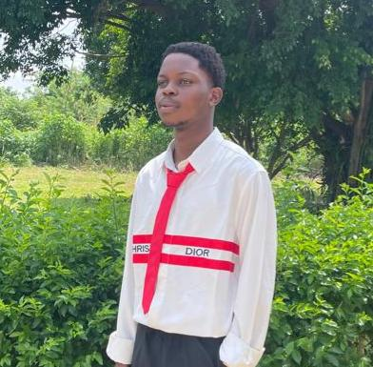
Oguntoyinbo Feranmi | Deput Editor-in-Chief
Oguntoyinbo Feranmi, a 400-level Medical Student with a strong interest in medicine, research, innovation, and entrepreneurship. I am passionate about continuous learning and evidence-based medicine, and I am always looking for opportunities to grow academically and professionally. I am also the CEO of DripZone, a lifestyle brand, and I have a keen interest in technology and business alongside my medical career.
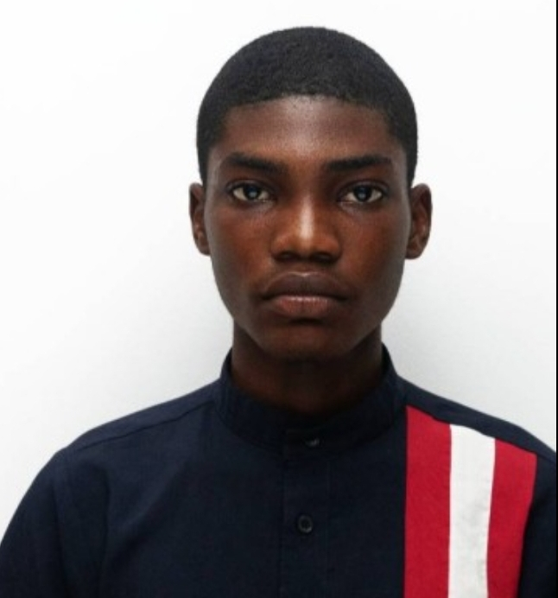
Toluwalowo Adekunle | Assistant Editor
Toluwalowo Adekunle is a third year medical student at Ekiti State University. He is passionate about research, with a particular interest in public health and epidemiology. He is currently developing his writing and organizational skills and hopes to pursue a career in preventive medicine or health policy. Outside academics, he enjoys reading novels, diving into webtoons, and binge-watching movies and series.

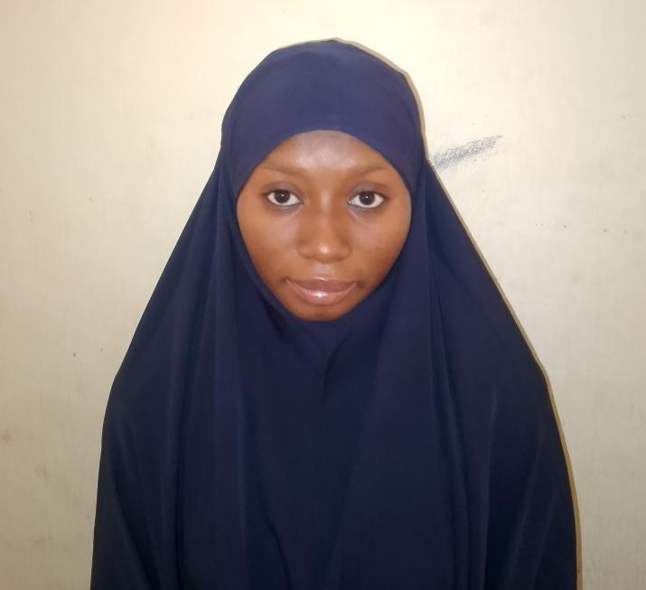

Abdurrazzaq Sumayyah | Assitant Editor
Abdurrazzaq Sumayyah is a 300-level medical student at Ekiti State University. She is passionate about research, with a particular interest in CRISPR and gene editing. She is currently developing her public speaking skills and hopes to pursue a career in gynecology. Outside academics, she enjoys sleeping and traveling.

